The following search problem has only three states and three directed edges. **S** is the start node, and **G** is the goal node. To the right, two different heuristic functions are defined, **h1**, and **h2**.

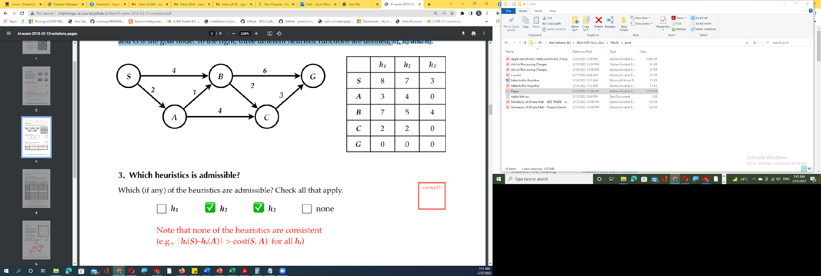

What solutions (i.e. path from S to G and total path cost) will be returned by

(a) A* tree search using the h1 heuristic, and

(b) A* tree search using the h2 heuristic

Task 1: Use a pen and paper to solve the problem.

Task 2: Write a code to build a priority queue to maintain the fringe for the A* search. Your code should have provisions for adding or deleting nodes from the queue.

Upload your solution to the Google Classroom by the deadline.